Hw #13/Romanticism and Realism

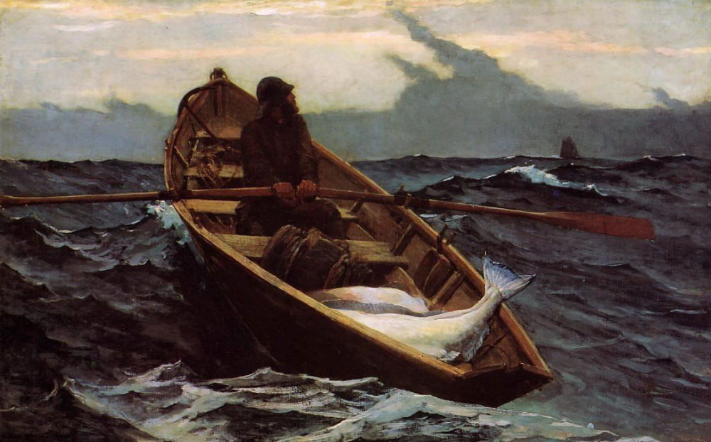
Fog Warning/Winslow Homer/1885

Fog Warning/Winslow Homer/1885
http://www.winslowhomer.org/the-fog-warning.jsp
http://www.mfa.org/collections/object/the-fog-warning-31042

Sifting through art images for this course is difficult because there are so many that I want to present for discussion, for example, Goya’s The Third of May and Delacroix’s Liberty Leading the People, both powerful paintings. This semester the American painter, Winslow Homer is pulling at my heart strings, and I have chosen his most famous painting, The Fog Warning. Describe the Romantic painting below for stylistic and thematic concerns. I also want you to consider the Transcendentalist movement in your response. The transcendentalists felt that spirituality and god could not be found in church doctrine but in nature. Nature was inherently sublime in all of its sensory and calm beauty, but also in its powerful glory. To the transcendentalists we are one with nature. Think about these lines from the poet, Walt Whitman Song of Myself, 1855.

I celebrate myself, and sing myself,
And what I assume you shall assume,
For every atom belonging to me as good belongs to you.

Then think of these lines from Walden (1854) by Henry David Thoreau:

I went to the woods because I wished to live deliberately, to front only the essential facts of life, and see if I could not learn what it had to teach, and not, when I came to die, discover that I had not lived. I did not wish to live what was not life, living is so dear, nor did I wish to practice resignation, unless it was quite necessary. I wanted to live deep and suck all the marrow of life, to live so sturdily and Spartan-like as to put to rout all that was not life, to cut a broad swath and shave close, to drive life into a corner, and reduce it to its lowest terms, and if it proved to be mean, why then to get the whole and genuine meanness of it, and publish its meanness to the world; or if it were sublime, to know it by experience, and be able to give a true account of it in my next excursion. For most men, it appears to me, are in a strange uncertainty about it, whether it is of the devil or of God, and have somewhat hastily concluded that it is the chief end of man here to “glorify God and enjoy him forever.”

How would you describe the idea of sublime nature in The Fog Warning?

All in all, you will be responding to the Romantic aspect of Winslow Homer’s painting as you describe it, but I would also like you to include aspects of Realism too. Be careful when discussing Realism that you don’t try to tell me about how real things look when that is not what the Realist Movement was about. Instead briefly explain the basic ideas of the Realist Movement and how you see the influence in this painting too. This painting clearly shows influences from the Romantic as well as the Realism Movement. One page.

